## The Perceptron

## The full perceptron model

## Model architecture

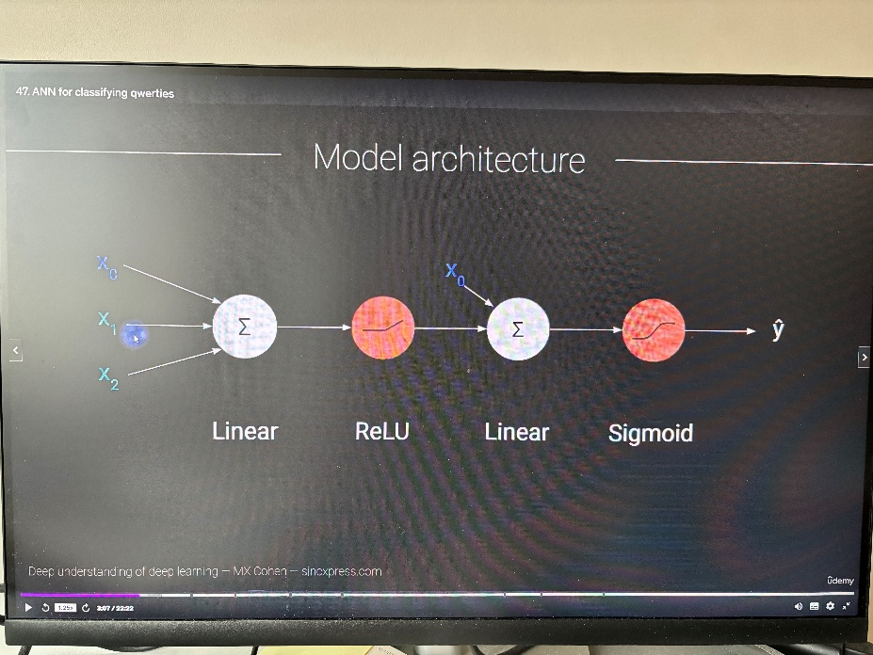

## Layers in DL networks

## 55. Depth vs. Width: number of parameters

# Section 8: Overfitting and cross-validation

## 62. Cross-validation

1. Cross-validation in general, see screenshots in order below

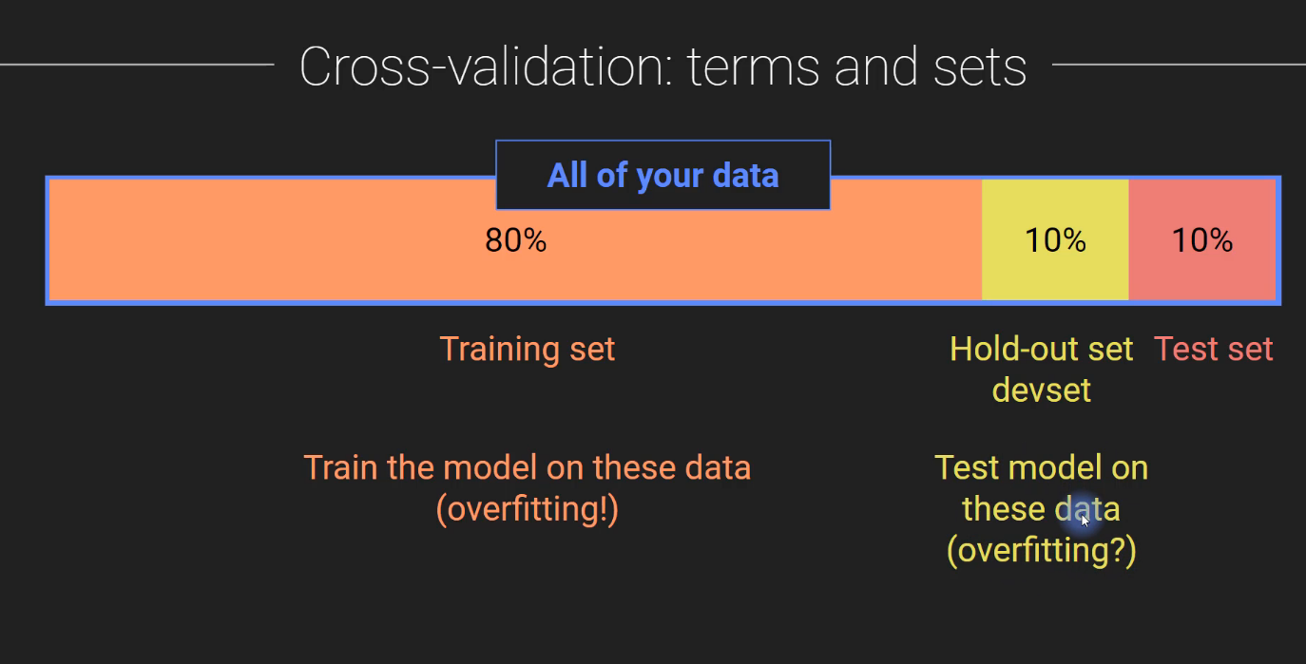

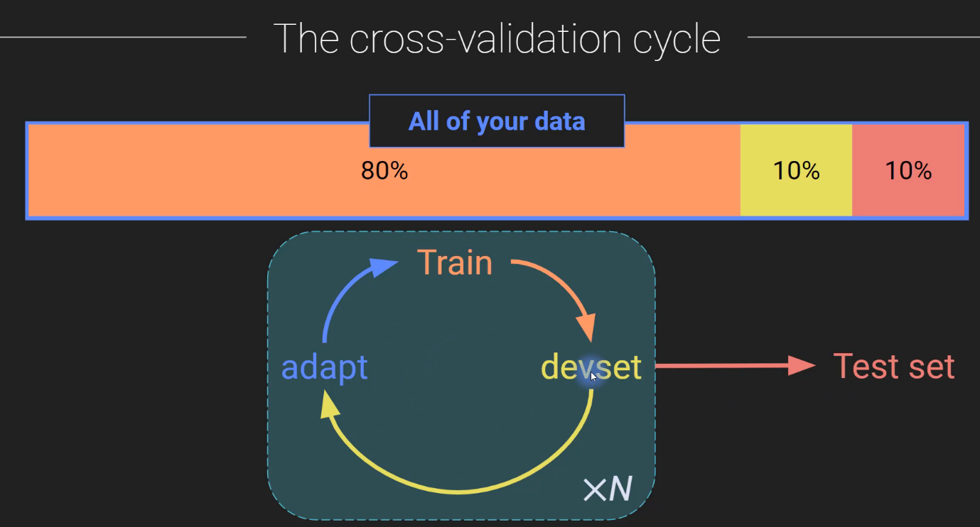

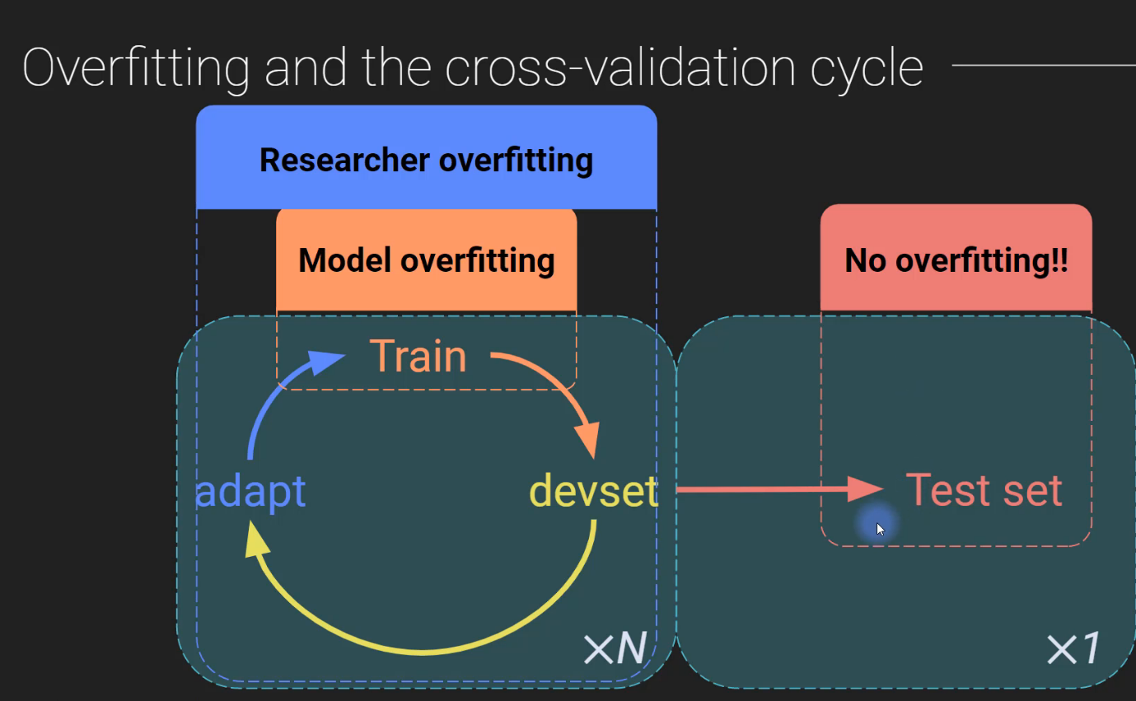

2. K-fold cross-validation, see screenshots in order below

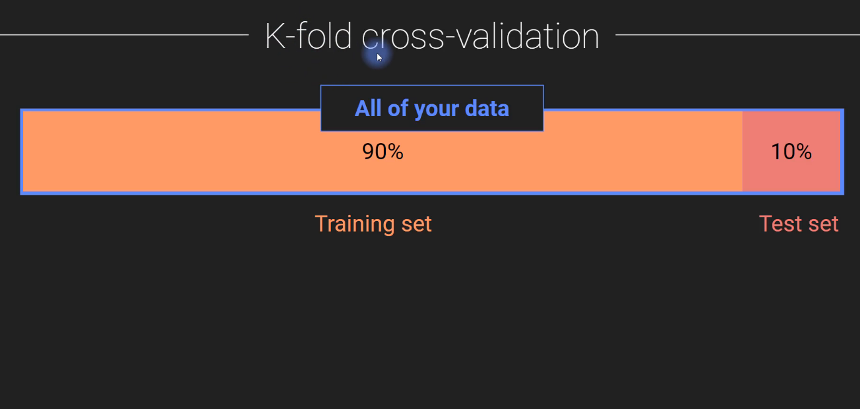

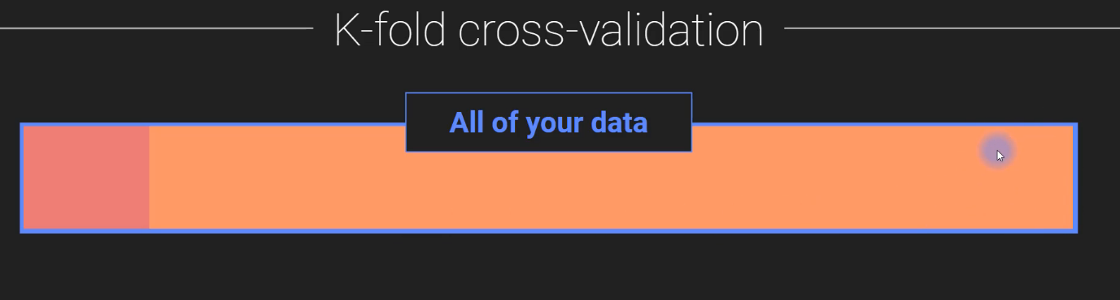

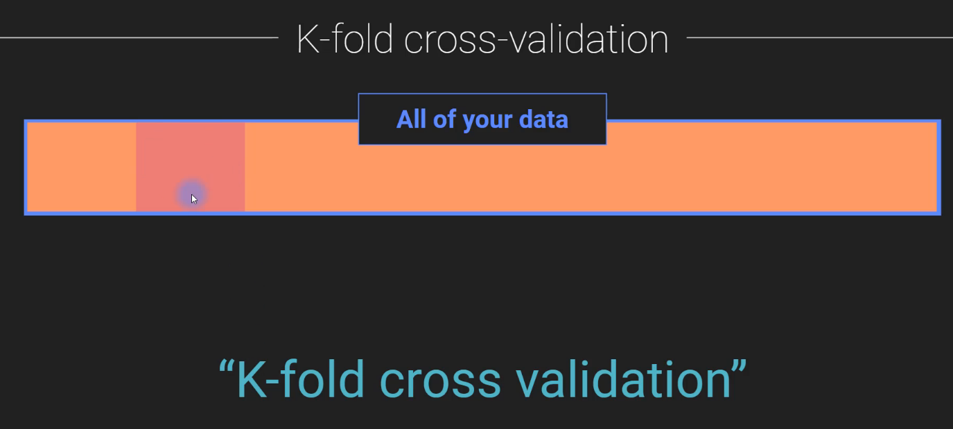

3. Underlying assumption that makes or breaks cross-validation (see screenshots in order)

